Latest Round-ups:
Season 2019/20
#6
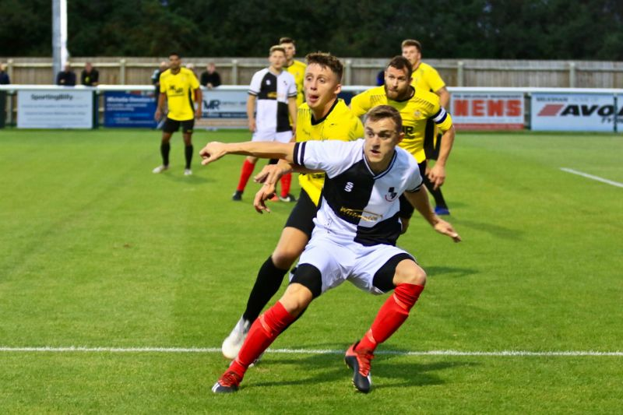
Midweek Action: It was a fantastic 24 hours for Western League side’s in the FA Cup at the beginning of the week, with a pair of wins over Southern League opponents. On Monday evening, Shepton Mallet continued their excellent early-season form with a 3-2 victory away at Melksham Town. The visitors went ahead in slightly fortunate fashion, when a long clearance by keeper Jonny Hill was deflected into the back of the net by Melksham defender Tom Warren midway through the first half. Mallet were very much in the ascendancy, and deservedly doubled their advantage on the half hour, when Joe Morgan angled the ball home from outside the box. It took just eight minutes for Shepton’s lead to evaporate after the interval, with Cameron Allen and Luke Ballinger scoring in quick succession to draw the home side level. The winning goal came soon after however, with Asa White prodding home from eight yards out after he was left unmarked following a corner which found its way to the back post. The following evening, Exmouth Town ushered in a crowd of 451 for their 2-0 victory over Yate Town. The opening half was devoid of goals, but that soon changed after the interval with Exmouth taking just two minutes to break the deadlock when Ben Steer knocked the ball into the Yate net. With 20 minutes left on the clock, Exmouth completed their memorable victory when Aaron Denny scored their second goal of the contest following a fine run from forward Ace High.
Action from Shepton Mallet’s FA Cup replay victory away at Melksham Town, courtesy of Haydn Jones.
On Wednesday, Bradford Town made it four wins from four in the Premier Division thanks to a 4-2 triumph at home to Bridport. After falling behind to Ryan Dovell’s 17th minute opener, Bradford turned the game around thanks to goals from Gary Higdon and Lewis Powell. Bridport’s Josh Phillips then levelled the scores ten minutes into the second half before strikes in the final quarter from Matt Morris and Tyson Pollard helped to maintain the Bobcats winning start.

FA Cup: Tavistock and Shepton Mallet will each play their fourth FA Cup tie in the space of ten days on Tuesday evening when they replay, following their 3-3 draw at Langsford Park on Saturday afternoon. Shepton enjoyed the best of the opening half, with Asa White handing them a dream start after less than five minutes. Reece Shanley levelled things up for the home side soon after, before Shepton surged ahead thanks to goals from Kieran Bailey and Joe Morgan. Tavistock pulled one back ten minutes after the interval through Jack Crago, with the same man then scoring the sixth and final goal of the contest 15 minutes from time to set up Tuesday’s replay. Elsewhere, it was a tough afternoon for other Western League sides in cup action, with Bradford Town falling to a 3-0 defeat in one of the day’s early kick-offs away at Sholing. Exmouth Town conceded twice in either half of their 4-2 loss away at Highworth Town, while Plymouth Parkway were beaten 1-0 by Merthyr Town at Bolitho Park. Bridgwater Town also fell short in their tie, with Harry Horton’s late strike capping a 3-1 defeat at the hands of Bristol Manor Farm.
Premier Division: Roman Glass St George claimed their first league win of the season in stunning fashion, hitting Wellington for eight at Oaklands Park. After Ryan Radford had given the hosts an early lead, they turned the screw at the end of the first half, scoring three goals in the space of three minutes. Radford doubled his tally to make it 2-0 in the 34th minute, with George Box then taking centre stage, scoring twice in quick succession to give Roman Glass a four-goal lead at the interval. The procession continued after the break, with a pair of substitutes – George Lloyd and Andy Gurney – getting in on the goalscoring action to extend the lead to six 20 minutes from time. Gurney was then fouled in the box which allowed Box to complete his hat-trick, with Lloyd finding time to score goal number eight in stoppage time. A late blitz from Bitton helped them to secure a 4-0 win at home to Buckland Athletic. An excellent finish from Matt Groves had given Bitton the lead midway through the first half, but they had to wait until the 70th minute before doubling their tally when leading scorer Josh Egan fired the ball home. The hosts added some gloss to the scoreboard in the closing stages, with Aysa Corrick and Egan extending the lead for the new league leaders. Brislington enjoyed their return to league action, scoring a late winner in their 2-1 triumph away at Bridport. Following defeats in both FA competitions over the past two weekends, Brislington hit the front at Bridport when Oaklan Buck headed home a pinpoint Mason Dagger cross. Bridport managed to find a way back into the game midway through the second half when Lewis Clarke equalised from the spot, but it was Brislington who took the spoils, when Mark Fear’s cross-come-shot nestled in the back of the net four minutes from time. Lucas Vowles of Clevedon was the star of the show during his side’s 3-0 victory over Cribbs at the Hand Stadium. Following a goalless opening half, Vowles opened the scoring three minutes after the restart thanks to an excellent through ball from George King. Vowles then turned provider, laying the ball off for Ethan Feltham to extend Clevedon’s lead, before Vowles returned to complete the scoring during the final ten minutes. In an entertaining clash at the Ridings, Chipping Sodbury twice came from behind to claim a 2-2 draw with Westbury United. The Wiltshire side forged ahead in stunning fashion at the end of the first half when Jordan Pinder hit an unstoppable drive from 25 yards out. No sooner had Nathan Brown levelled affairs, Westbury retook the lead when Ricky Hulbert lashed the ball home. With defeat looking likely, Chipping Sodbury turned to a now reliable source of goals, with Sam Makepeace extending his incredible record to start the season when he struck an equaliser six minutes from time to rescue a point. An own goal two minutes into the second half decided the destination of the points in Bath, where Cadbury Heath claimed a 1-0 win over Odd Down.
Action from Roman Glass’s thumping win over Wellington.
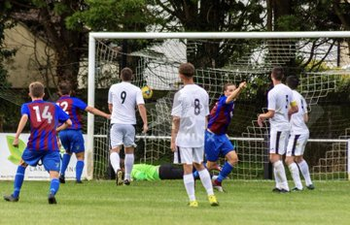
First Division: Wells City continued their promising start to the season with a dramatic 3-2 victory at home to Warminster Town. It took all of ten minutes for the home side to go ahead at the Athletic Ground, with one of last week’s FA Vase hero’s Ross Padfield finding the net once again. Warminster battled hard after going behind, and got a deserved equaliser from Lewis Graham midway through the second half, but they didn’t stay on level terms for long, with Padfield restoring the hosts’ lead. Having already come from behind earlier in the match, Warminster looked to have rescued a draw when Jack Miluk headed the ball home, yet Wells and Padfield would not be denied, and with just two minutes left in normal time, the frontman completed his hat-trick to claim a fourth league win of the season. There was also a late winner in the game at Bowdens Park, where Cheddar defeated Sherborne 2-1 to extend their perfect start. After Adam Wright had struck at the near post to put Cheddar ahead, Sherborne got themselves back on level terms in the early stages of the second half through Alex Murphy. With the clock winding down, Wright brought himself just enough room in the visitors box to fire home a late winner to make it four victories from four for the Cheesemen. Late goals were very much a recurring theme on Saturday afternoon, with Alex Hoyle’s 89th minute effort handing early season pacesetters Oldland Abbotonians a 1-0 win over Almondsbury at the Aitchison Playing Field. Calne were hit by a sucker-punch in the closing stages of their home game against Ashton & Backwell United, with the away side taking all three points thanks to an injury time goal from Sam Thomas.
Ashton & Backwell celebrate scoring their injury-time winner at Bremhill View against Calne.
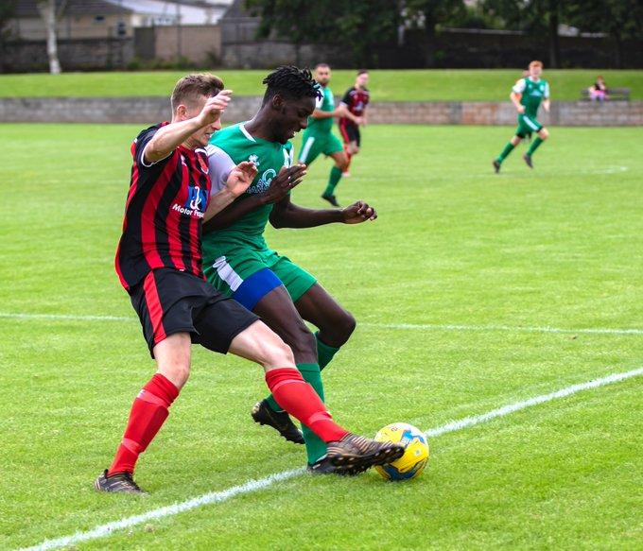
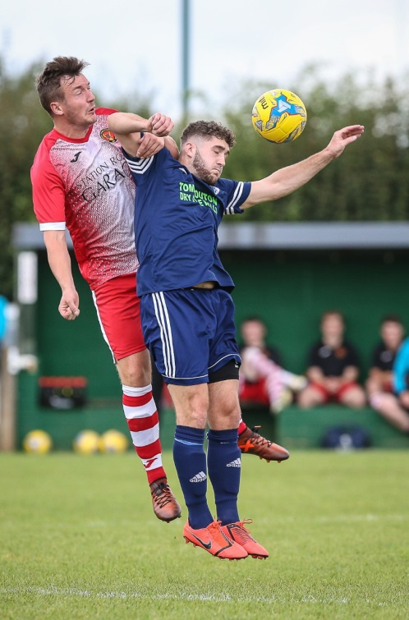
Devizes Town claimed their first league win of the season, scoring four times in the final 20 minutes to defeat Hengrove Athletic 5-1. Having taken the lead after 15 minutes through Matt Swann, Devizes conceded an equaliser on the hour mark to a Hengrove side who were also going in search of their first three points this term. Jamie Wallen made a huge impact after entering the game for Devizes, scoring three times as a second half substitute to add to Hengrove’s early season woes. Bishop Sutton are another side who have struggled over the first month of the campaign, and they were handed a 4-1 defeat away at Portishead, with Jack Sell, Ollie Carter, Louie Elliot and Liam Villis all finding the back of the net for the hosts. Wincanton Town picked up where they left off a fortnight ago, scoring twice in either half to beat Corsham 4-0 at the Southbank Ground. Having surprisingly drawn a blank coming into this game, Connor Williams finally got off the mark this season for the Wasps with a well-taken brace, adding to further goals from Toby Cole and Louis Irwin. At West Clewes, Welton Rovers picked up their first win since the opening day of the season, after Rene Adigbo’s goal five minutes before the break helped them beat Bishops Lydeard 1-0. In the game of the day, Longwell Green Sports won an eight-goal thriller at home to Lebeq United, fighting back from a pair of recent losses with a 5-3 win at Shellards Road. Danny Carter was in fantastic form for the Bristol club, scoring three of his side’s five goals during the tie. In another high-scoring fixture, Radstock staged a terrific fightback to beat basement side Bristol Telephones 3-2 at Stockwood Lane. Having lost all four of their league fixtures during August, Telephones must have thought their luck had turned when they powered into a two-goal lead after just nine minutes. The Miners came close on a couple of occasions during the opening spell of the game, but had to wait until the half-hour mark to finally find the back of the net with James Rustell firing home from the penalty spot. Jack Biddiscombe played a huge role after the break, firstly providing a tantalising cross which ended at the feet of Rustell who lashed home the equaliser. With time running out, Biddiscombe was the fulcrum of another Radstock attack, providing a cross for substitute Rico Sobers to steer the winning goal past the Phones’ keeper.
Welton matchwinner Rene Adigbo in action during their victory over Bishops Lydeard.
Wincanton goalscorer Jamie Irwin challenges for a header against Corsham’s James Gardner during their 4-0 win. Image courtesy of John Cuthbertson.
Latest Results
Monday 2nd September 2019
FA Cup Extra Preliminary Round Replay
Melksham Town 2-3 Shepton Mallet
Tuesday 3rd September 2019
FA Cup Extra Preliminary Round Replay
Exmouth Town 2-0 Yate Town 451
Wednesday 4th September 2019
Premier Division
Bradford Town 4-2 Bridport 114
Saturday 7th September 2019
FA Cup – First Qualifying Round
Bridgwater Town 1-3 Bristol Manor Farm 291
Highworth Town 4-2 Exmouth Town
Plymouth Parkway 0-1 Merthyr Town 201
Sholing 3-0 Bradford Town 201
Tavistock 3-3 Shepton Mallet 145
Premier Division
Bitton 4-0 Buckland Athletic 92
Bridport 1-2 Brislington 100
Chipping Sodbury Town 2-2 Westbury United 82
Clevedon Town 3-0 Cribbs 124
Odd Down 0-1 Cadbury Heath 67
Roman Glass St George 8-0 Wellington 40
First Division
Bristol Telephones 2-3 Radstock Town 52
Calne Town 0-1 Ashton & Backwell United 76
Cheddar 2-1 Sherborne Town 77
Corsham Town 0-4 Wincanton Town 89
Hengrove Athletic 1-5 Devizes Town 47
Longwell Green Sports 5-3 Lebeq United 95
Oldland Abbotonians 1-0 Almondsbury
Portishead Town 4-1 Bishop Sutton 47
Wells City 3-2 Warminster Town 72
Welton Rovers 1-0 Bishops Lydeard 77

Be sure to check out the latest podcast, where Ian, Tom & guests recap all the latest news and results from around the Western League. To follow along all season, each broadcast will be available at the following link: http://www.toolstationleague.com/podcasts.php

Upcoming Fixtures
Tuesday 10th September 2019
FA Cup – First Qualifying Round Replay
Shepton Mallet vs Tavistock 19:30KO
Premier Division
Brislington vs Westbury United 19:30KO
Keynsham Town vs Clevedon Town 19:45KO
Wednesday 11th September 2019
Premier Division
Street vs Plymouth Parkway 19:30KO
First Division
Oldland Abbotonians vs Hengrove Athletic 19:45KO
Saturday 14th September 2019 (KICK OFF AT 3.00PM UNLESS NOTED)
FA Vase – Second Qualifying Round
Alton vs Westbury United
Bodmin Town vs Buckland Athletic
Bradford Town vs Hamble Club
Cadbury Heath vs Exmouth Town
Camelford vs Ashton & Backwell United
Cheddar vs Tavistock
Corsham Town vs Romsey Town
Devizes Town vs Newport (IoW)
Downton vs Wincanton Town
Ivybridge vs Roman Glass St George
Radstock Town vs Bovey Tracey
Shepton Mallet vs Street
Sherborne Town vs Petersfield Town
Torpoint Athletic vs Portishead Town
Warminster Town vs Alresford Town
Wells City vs Newton Abbot Spurs
Premier Division
Bridport vs Keynsham Town
Brislington vs Wellington
Chipping Sodbury Town vs Cribbs
Hallen vs Bridgwater Town
Plymouth Parkway vs Odd Down

League Tables
Premier Division
 |  | P | W | D | L | F | A | GD | PTS
1 | Bitton | 5 | 4 | 0 | 1 | 21 | 4 | 17 | 12
2 | Bradford Town | 4 | 4 | 0 | 0 | 14 | 6 | 8 | 12
3 | Plymouth Parkway | 4 | 3 | 0 | 1 | 13 | 3 | 10 | 9
4 | Odd Down | 6 | 3 | 0 | 3 | 12 | 10 | 2 | 9
5 | Brislington | 4 | 3 | 0 | 1 | 9 | 10 | -1 | 9
6 | Bridgwater Town | 4 | 2 | 1 | 1 | 12 | 4 | 8 | 7
7 | Clevedon Town | 4 | 2 | 1 | 1 | 9 | 5 | 4 | 7
8 | Shepton Mallet | 3 | 2 | 1 | 0 | 8 | 4 | 4 | 7
9 | Westbury United | 4 | 2 | 1 | 1 | 9 | 7 | 2 | 7
10 | Tavistock | 3 | 2 | 0 | 1 | 9 | 5 | 4 | 6
11 | Exmouth Town | 3 | 2 | 0 | 1 | 5 | 2 | 3 | 6
12 | Street | 3 | 2 | 0 | 1 | 8 | 6 | 2 | 6
13 | Keynsham Town | 4 | 2 | 0 | 2 | 7 | 7 | 0 | 6
14 | Hallen | 3 | 2 | 0 | 1 | 6 | 7 | -1 | 6
15 | Buckland Athletic | 5 | 2 | 0 | 3 | 7 | 12 | -5 | 6
16 | Cadbury Heath | 5 | 2 | 0 | 3 | 8 | 14 | -6 | 6
17 | Chipping Sodbury Town | 6 | 1 | 1 | 4 | 7 | 23 | -16 | 4
18 | Roman Glass St George | 4 | 1 | 0 | 3 | 11 | 6 | 5 | 3
19 | Bridport | 6 | 1 | 0 | 5 | 6 | 19 | -13 | 3
20 | Cribbs | 5 | 0 | 1 | 4 | 3 | 14 | -11 | 1
21 | Wellington | 5 | 0 | 0 | 5 | 3 | 19 | -16 | 0

First Division
 |  | P | W | D | L | F | A | GD | PTS
1 | Oldland Abbotonians | 6 | 4 | 1 | 1 | 8 | 7 | 1 | 13
2 | Calne Town | 6 | 4 | 0 | 2 | 13 | 5 | 8 | 12
3 | Cheddar | 4 | 4 | 0 | 0 | 12 | 5 | 7 | 12
4 | Wells City | 5 | 4 | 0 | 1 | 14 | 9 | 5 | 12
5 | Wincanton Town | 5 | 3 | 2 | 0 | 15 | 7 | 8 | 11
6 | Ashton & Backwell United | 5 | 3 | 1 | 1 | 9 | 7 | 2 | 10
7 | Radstock Town | 5 | 3 | 0 | 2 | 15 | 9 | 6 | 9
8 | Portishead Town | 5 | 3 | 0 | 2 | 12 | 9 | 3 | 9
9 | Longwell Green Sports | 5 | 3 | 0 | 2 | 11 | 8 | 3 | 9
10 | Sherborne Town | 5 | 3 | 0 | 2 | 10 | 9 | 1 | 9
11 | Bishops Lydeard | 5 | 2 | 0 | 3 | 13 | 9 | 4 | 6
12 | Warminster Town | 5 | 2 | 0 | 3 | 11 | 9 | 2 | 6
13 | Welton Rovers | 4 | 2 | 0 | 2 | 3 | 5 | -2 | 6
14 | Lebeq United | 5 | 2 | 0 | 3 | 9 | 13 | -4 | 6
15 | Corsham Town | 6 | 2 | 0 | 4 | 10 | 18 | -8 | 6
16 | Almondsbury | 5 | 1 | 1 | 3 | 4 | 6 | -2 | 4
17 | Devizes Town | 4 | 1 | 0 | 3 | 10 | 12 | -2 | 3
18 | Bishop Sutton | 5 | 1 | 0 | 4 | 5 | 10 | -5 | 3
19 | Hengrove Athletic | 5 | 0 | 1 | 4 | 2 | 21 | -19 | 1
20 | Bristol Telephones | 5 | 0 | 0 | 5 | 5 | 13 | -8 | 0

